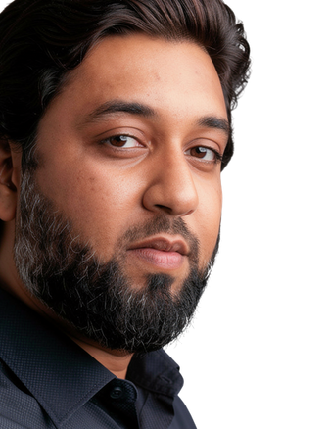

IZHAR UL HAQ
F R E E L A N C E R
ABOUT MYSELF

MY CONTACT
Phone
0313-2391292
Email
izharulhaq1981@gmail.com
Address
A-189 block 13-A Gulshan e iqbal karachi sindh

EXPERTISE
- E-Commerce
- WordPress
- Shopify
- Web design
- Design logo
- Favicon
- Excel Projects
- HRD Recruitment and Dashboard creation

REFERENCES
I am a multi-skilled freelancer specializing in Human Resource Development, Graphic Designing, and Web Development. I create impactful digital solutions ranging from Shopify and WordPress websites to Canva carousels, social media posts, thumbnails, favicons, and product mockups.
With a commitment to quality and creativity, I help brands strengthen their online presence through clean design, functional websites, and strategic visual communication.
Always ready to collaborate and bring ideas to life.
"Lets Connect and explore how i can help drive your online success.

EXPERIENCE
Fresher
GRAPHIC DESIGNER /WEB

DEVELOPMENT
Textile Auxiliaries Company HR Executive 2023 to 2025

EDUCATION

Furnish upon request
2018
University of karachi
I have done my Masters MHRM “Masters in Human Resource Management

1


Job Responsibility & Majors
- Employee Hiring process
- Employee confirmation process
- Employee Termination process
- Payroll procedure
- Maintain Attendance Management
- Employees conflicts
- MRM
- IOM
- Internal stakeholders’ procedures
- External Stakeholders connectivity
- Implementation of Control Documents
- Implementation of Company Policy
- HR Departmental SOP, s
- HR KPIs
- Department KPI,s
- EOBI and SESSI Contributions
- Employee Loan and Advances
- Complete process of inward/outward visa
- Air/bus/Train tickets of employees
- Complete process of transfer vehicles, Transit, Transfer letters, Delivery Letters
- Performance Appraisal System(Yearly,Quarterly,Monthly 22. )Evaluation .
- Employee Testing by Hue Munsell
- Data Analysis
- Complete Generalist role and
Responsibilities and Recruitment 2
process on boarding and off boarding

